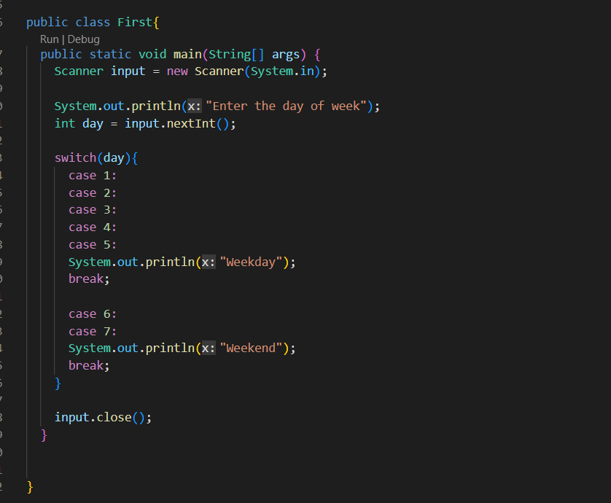

I might think of using 1||2||3||4||5 instead use this method